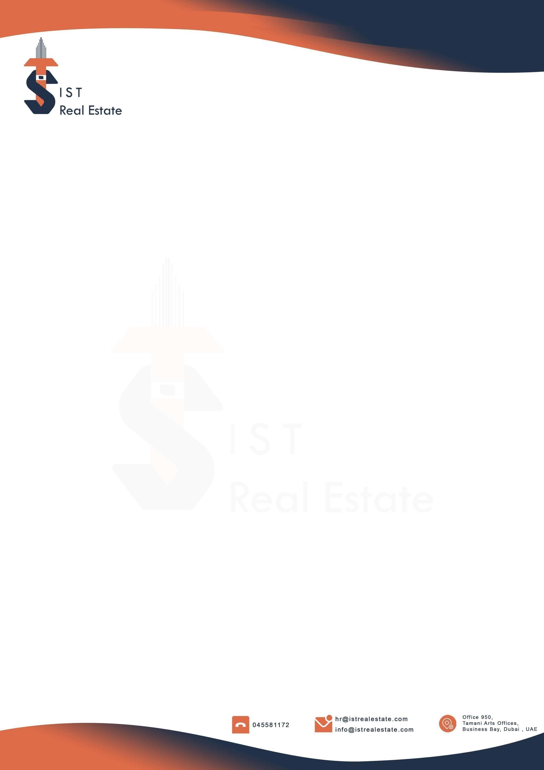

NAME : AHMAD ZOHERY
DEPARTMENT : IST Markets
DATE : 24 JAN 2026

OFFER OF EMPLOYMENT – SUBJECT TO CONTRACT

Dear Ahmad Zohery,

We are pleased to offer you the position of SEO Executive at I S T Markets. We were thoroughly impressed by your qualifications, experience, and interview performance, and we believe you will make a valuable contribution to our team.

The Terms and conditions of your employment will be as follows:

- Salary: 5000 AED Per Month
- Commission: Commission Structure as per performance
- Probation Period: 6 Months.
- Working Hours: 10:00 AM to 7:00 PM, Monday to Friday
10:00 AM to 3:00 PM, Saturday
- Annual Leave: 30 Days as per UAE Labor Law
- Employment Visa: Company-sponsored UAE residence visa and medical insurance
- Anticipated Start Date: 26 Jan 2026

1) Roles and Responsibilities:
- You are offered the position of SEO Executive, reporting to [Head of Marketing / SEO Lead]. Your primary scope is SEO execution across IST Groups’ digital brands, with emphasis on IST Markets (istmarkets.com, istmarkets.mu) and, when assigned, IST Real Estate (istrealestate.ae, istrealestate.com), and their social channels.
- Content Creation (SEO-led): You will ideate, draft, and publish SEO-optimized content for both websites entities (blogs, guides, landing pages), and create search-optimized scripts and copy for Reels, Carousel posts, and Stories across Meta (Facebook, Instagram, Threads), X.com, YouTube, TikTok, and Snapchat. All social content must comply with each platform’s policies (including Meta’s policies), reflect white-hat practices, and be produced to maximize search discoverability and audience engagement.
2) Employer & Group Assignment
- Your legal employer is IST Real Estate (part of IST Groups). You may be assigned work across IST Groups brands, including IST Markets, as business needs require. Such assignments do not change your employing entity or the terms of this offer.
3) Work Hours, Breaks, Ramadan & Overtime
- Normal hours: 8 hours per day, up to 48 hours per week in line with UAE Labour Law.
- Schedule: Monday–Friday 10:00–19:00 and Saturday 10:00–15:00, including a 1-hour unpaid meal break on weekdays.

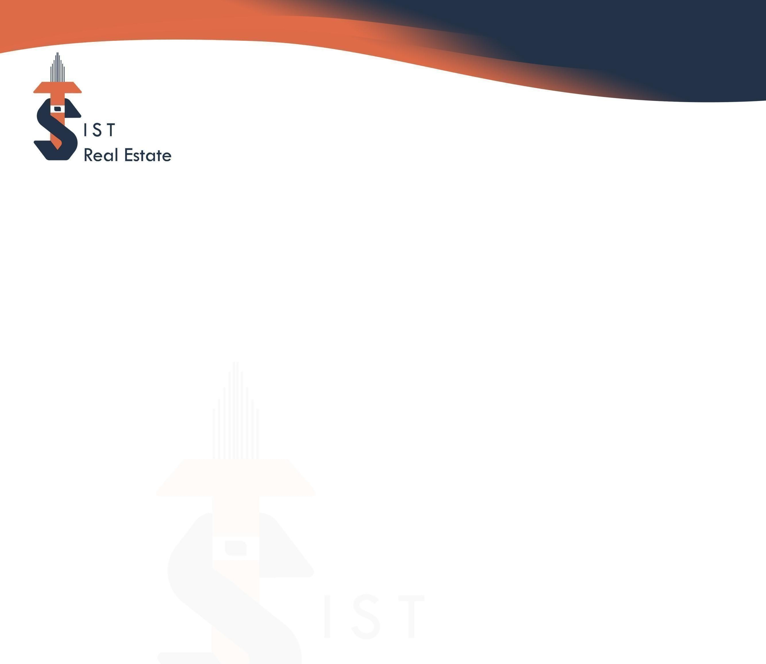


Ramadan: Daily working hours are reduced by 2 hours.
- Overtime: Any work beyond the above requires prior written approval and is compensated per UAE Labour Law and company policy (overtime pay or time off in lieu).
4) Compensation
- Base Salary: AED 5,000 per month, paid monthly in arrears (all-in; separate allowances are not provided).
- Benefits: Visa sponsorship and medical insurance per company policy.
- Annual Leave & Holidays: 30 calendar days of paid annual leave per completed year of service, plus UAE public holidays, in accordance with company policy.

5) Semiannual Discretionary Bonus (Management Discretion)
- You are eligible for performance Bonus tied to audited SEO KPIs, in line with company policy and the KPI scorecard.
Note: Bonus is subject to management discretion and the outcome of audited SEO KPIs. This bonus is not guaranteed and may vary in amount or may not be awarded.
Eligibility & Timing: You must be employed and in good standing on the bonus payout date. Payouts, if any, will be processed within 30 days following the semiannual review window.
Attribution & Audit: Organic performance must be reasonably attributable to organic non-brand research and documented per Evidence & Attribution rules. Management reserves the right to adjust or withhold the bonus based on audit findings, policy violations, or business conditions.
5.1) Quality Gate, Attribution & Clawbacks
- Quality Gate: No payout if spammy links (PBNs, link schemes), policy/regulatory breaches (e.g., compliance issues for finance; DLD/RERA/Trakheesi for real estate), or invalid traffic are identified.
- Attribution: Organic performance must be attributable to Organic Search (GA4) with non-brand filtering (GSC query filters / brand-exclusion regex). GBP traffic must be UTM-tagged; calls/messages validated via GBP/telephony exports.
- Audit evidence: GA4, GSC, GBP, platform dashboards, and CRM/BI exports may be requested.
- Clawbacks: Reversed/invalid leads, chargebacks, or compliance violations identified within 90 days after payout will be deducted from the next commission/bonus payout.

6) Probation & Notices
- Probation: 6 months from Start Date.
- Notice during probation (Employer): 14 days.
- Notice during probation (Employee): 14–30 days (per UAE Labour Law, depending on whether you are transferring within the UAE or leaving the UAE).
- Post-probation notice: 30 days (both parties), unless amended by law or policy.

7) Duties, Conduct & Intellectual Property
- You shall perform your duties diligently, follow all policies, and not engage in conflicts of interest. All work products, code, content, and data created in the course of employment are the intellectual property of IST Real Estate L.L.C, IST Markets / IST Groups. You must always maintain confidentiality of company and customer data.
8) Data Protection & Confidentiality
- You agree to comply with internal information security standards and applicable data-protection requirements. Confidential information must not be disclosed during or after employment.

9) Company Property & Exit
- Upon termination, you must return all company property and remove company data from personal devices. Final settlement will be processed by UAE Labour Law.
10) Governing Law & Dispute Resolution
- This offer and your employment are governed by the laws of the United Arab Emirates. The Dubai Courts shall have jurisdiction, unless UAE law mandates otherwise.
11) Content Standards & Platform Compliance
- All content must be white-hat and compliant with the current policies of each platform, including Meta (Facebook, Instagram, Threads), X.com, YouTube, TikTok, and Snapchat. Content must follow platform community guidelines, ad policies, intellectual property rules, disclosures, and applicable UAE regulations.
- Creative outputs must be SEO-first (titles, hooks, captions, hashtags, thumbnails, chapters) and designed to maximize discoverability and engagement while meeting the Quality Gate (no spammy links, no review gating, accurate claims, proper UTMs).
12) Entire Agreement & Variations


- This letter constitutes the entire agreement relating to compensation structure and supersedes prior understandings. The Company may modify policies and KPI targets prospectively, with reasonable written notice
Acceptance of this offer, along with an email confirmation, is required, including your signature and the date to confirm your agreement with the proposed terms, policies, and HR Manual of the company. This offer is valid for a period of three working days from the date of issuance.
We are excited to have you onboard and look forward to working with you. Please feel free to contact us should you have any questions or wish to discuss any aspects of the above.

Yours Sincerely
Mohammed Shahbaaz Signature:
HR Specialist Date:

